|  |  |
| --- | --- |
| Date | 01 OCT 2022 |
| Team ID | PNT2022TMID34509 |
| Project Name | Predicting the energy output of wind turbine based on weather condition |
| Maximum Marks | 2 Marks |

Project Design Phase-I

Solution Architecture

Solution Architecture:

Many developments and improvements have taken place since the commercialisation of wind technology in the early 1980s, but the basic architecture of the mainstream design has changed very little. Most wind turbines have upwind rotors and are actively yawed to preserve alignment with the wind direction. The three-bladed rotor proliferates and typically has a separate front bearing, with low speed shaft connected to a gearbox that provides an output speed suitable for the most popular four-pole (or two -pole) generators. This general architecture is evident in Figure 3.6. Commonly, with the largest wind turbines, the blade pitch will be varied continuously under active control to regulate power in higher operational wind speeds. Support structures are most commonly tubular steel towers tapering in some way, both in metal wall thickness and in diameter from tower base to tower top. Concrete towers, concrete bases with steel upper sections and lattice towers, are also used but are much less prevalent. Tower height is rather site specific and turbines are commonly available with three or more tower height options

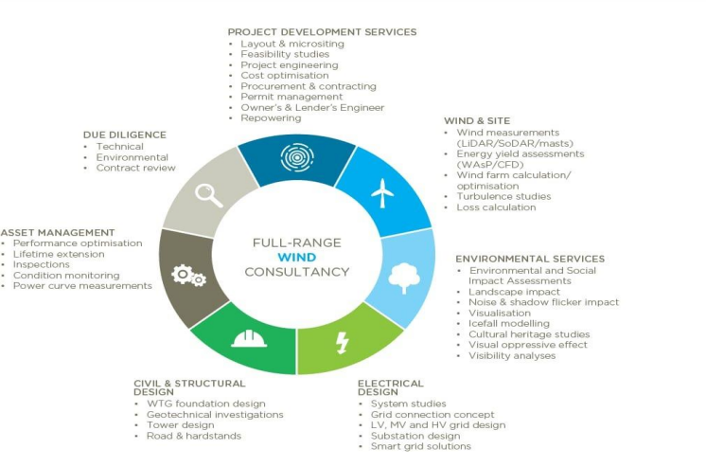

ARCHITECTURE DIAGRAM FOR PREDICTING THE ENERGY OUTPUT OF WIND TURBINE BASED ON WEATHER CONDITION